­What is Cloud?

The term **Cloud** refers to a **Network** or **Internet.** In other words, we can say that Cloud is something, which is present at remote location.

Cloud can provide services over public and private networks, i.e., WAN, LAN or VPN. Applications such as e-mail, web conferencing, customer relationship management (CRM) execute on cloud.

What is Cloud Computing?

It is a technology that uses remote servers on the internet to store, manage, and access data online rather than local drives. The data can be anything such as files, images, documents, audio, video, and more.

Cloud Computing provides us means of accessing the applications as utilities over the Internet. It allows us to create, configure, and customize the applications online.

There are the following operations that we can do using cloud computing:

* Developing new applications and services
* Storage, back up, and recovery of data
* Hosting blogs and websites
* Delivery of software on demand
* Analysis of data
* Streaming videos and audios

On demand delivery of IT resources through the Internet with payment depending on the use of the service is known as **cloud computing.**

* It accesses the multiple server-based computer resources through a network.
* Cloud user accesses the server resources using the computer, smart phones, notebook, tablets or other devices.
* Cloud server maintains all the processing and storage.

# History of Cloud Computing

Before emerging the cloud computing, there was Client/Server computing which is basically a centralized storage in which all the software applications, all the data and all the controls are resided on the server side.

If a single user wants to access specific data or run a program, he/she need to connect to the server and then gain appropriate access, and then he/she can do his/her business.

Then after, distributed computing came into picture, where all the computers are networked together and share their resources when needed.

On the basis of above computing, there was emerged of cloud computing concepts that later implemented.

At around in 1961, John MacCharty suggested in a speech at MIT that computing can be sold like a utility, just like a water or electricity. It was a brilliant idea, but like all brilliant ideas, it was ahead if its time, as for the next few decades, despite interest in the model, the technology simply was not ready for it.

But of course time has passed and the technology caught that idea and after few years we mentioned that:

In 1999, **Salesforce.com** started delivering of applications to users using a simple website. The applications were delivered to enterprises over the Internet, and this way the dream of computing sold as utility were true.

In 2002, **Amazon** started Amazon Web Services, providing services like storage, computation and even human intelligence. However, only starting with the launch of the Elastic Compute Cloud in 2006 a truly commercial service open to everybody existed.

In 2009, **Google Apps** also started to provide cloud computing enterprise applications.

Of course, all the big players are present in the cloud computing evolution, some were earlier, some were later. In 2009, **Microsoft** launched Windows Azure, and companies like Oracle and HP have all joined the game. This proves that today, cloud computing has become mainstream.

Why Cloud Computing/ importance

Small as well as large IT companies, follow the traditional methods to provide the IT infrastructure. That means **for any IT company, we need a Server Room that is the basic need of IT companies**.

In that server room, there should be a database server, mail server, networking, firewalls, routers, modem, switches, QPS (Query Per Second means how much queries or load will be handled by the server), configurable system, high net speed, and the maintenance engineers.

To establish such IT infrastructure, we need to spend lots of money. To overcome all these problems and to reduce the IT infrastructure cost, Cloud Computing comes into existence.

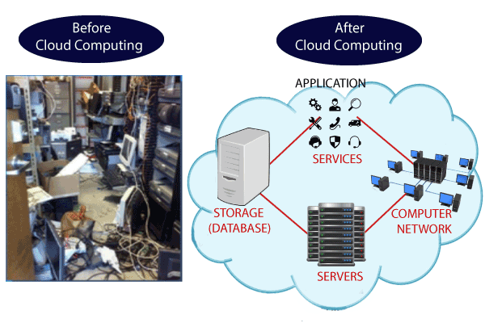

Characteristics of Cloud Computing

The characteristics of cloud computing are given below:

**1) Agility**

The cloud **works in a distributed computing environment**. It shares resources among users and works very fast.

**2) High availability and reliability**

The availability of servers is high and more reliable because the **chances of infrastructure failure are minimum**.

**3) High Scalability**

Cloud offers **"on-demand" provisioning of resources on a large scale**, without having engineers for peak loads.

**4) Multi-Sharing**

With the help of cloud computing, **multiple users and applications can work more efficiently** with cost reductions by sharing common infrastructure.

**5) Device and Location Independence**

Cloud computing enables the users to access systems using a web browser regardless of their location or what device they use e.g. PC, mobile phone, etc. **As infrastructure is off-site** (typically provided by a third-party) **and accessed via the Internet, users can connect from anywhere**.

**6) Maintenance**

Maintenance of cloud computing applications is easier, since they **do not need to be installed on each user's computer and can be accessed from different places**. So, it reduces the cost also.

**7) Low Cost**

By using cloud computing, the cost will be reduced because to take the services of cloud computing, **IT company need not to set its own infrastructure** and pay-as-per usage of resources.

**8) Services in the pay-per-use mode**

Application Programming Interfaces**(APIs) are provided to the users so that they can access services on the cloud** by using these APIs **and pay the charges as per the usage of services**.

# Advantages and Disadvantages of Cloud Computing

## Advantages of Cloud Computing

As we all know that Cloud computing is trending technology. Almost every company switched their services on the cloud to rise the company growth.

Here, we are going to discuss some important advantages of Cloud Computing-

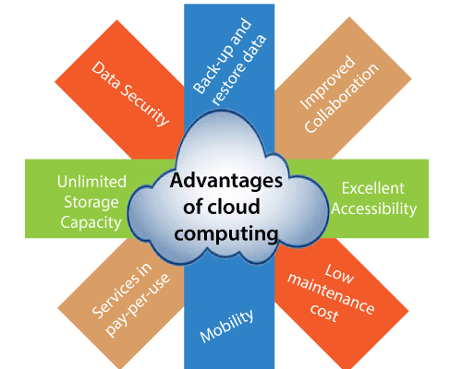

### 1) Back-up and restore data

Once the data is stored in the cloud, it is easier to get back-up and restore that data using the cloud.

### 2) Improved collaboration

Cloud applications improve collaboration by allowing groups of people to quickly and easily share information in the cloud via shared storage.

### 3) Excellent accessibility

Cloud allows us to quickly and easily access store information anywhere, anytime in the whole world, using an internet connection. An internet cloud infrastructure increases organization productivity and efficiency by ensuring that our data is always accessible.

### 4) Low maintenance cost

Cloud computing reduces both hardware and software maintenance costs for organizations.

### 5) Mobility

Cloud computing allows us to easily access all cloud data via mobile.

### 6) IServices in the pay-per-use model

Cloud computing offers Application Programming Interfaces (APIs) to the users for access services on the cloud and pays the charges as per the usage of service.

### 7) Unlimited storage capacity

Cloud offers us a huge amount of storing capacity for storing our important data such as documents, images, audio, video, etc. in one place.

### 8) Data security

Data security is one of the biggest advantages of cloud computing. Cloud offers many advanced features related to security and ensures that data is securely stored and handled.

## Disadvantages of Cloud Computing

A list of the disadvantage of cloud computing is given below -

### 1) Internet Connectivity

As you know, in cloud computing, every data (image, audio, video, etc.) is stored on the cloud, and we access these data through the cloud by using the internet connection. If you do not have good internet connectivity, you cannot access these data. However, we have no any other way to access data from the cloud.

### 2) Vendor lock-in

Vendor lock-in is the biggest disadvantage of cloud computing. Organizations may face problems when transferring their services from one vendor to another. As different vendors provide different platforms, that can cause difficulty moving from one cloud to another.

### 3) Limited Control

As we know, cloud infrastructure is completely owned, managed, and monitored by the service provider, so the cloud users have less control over the function and execution of services within a cloud infrastructure.

### 4) Security

Although cloud service providers implement the best security standards to store important information. But, before adopting cloud technology, you should be aware that you will be sending all your organization's sensitive information to a third party, i.e., a cloud computing service provider. While sending the data on the cloud, there may be a chance that your organization's information is hacked by Hackers.

5) Insecure or Incomplete Data Deletion

It is possible that the data requested for deletion may not get deleted. It happens because either of the following reasons

* Extra copies of data are stored but are not available at the time of deletion
* Disk that stores data of multiple tenants is destroyed.